Cover Page

ASSIGNMENT # 4 VLAN CONFIGURATION

Date of submission: Dec. 18, 2017

Name of each team member and part of the assignment he completed:

Bishop Osborne – completed Router, Host-A, Screenshots.

Joshua Fontana – completed switch S1, Screenshots.

Nikola Petrovski – completed switch S2, Host-B, Screenshots.

Timothy Molga – completed switch S3, Host-C, Screenshots.

1. **NETWORK TOPOLOGY IN GNS3 (4)**

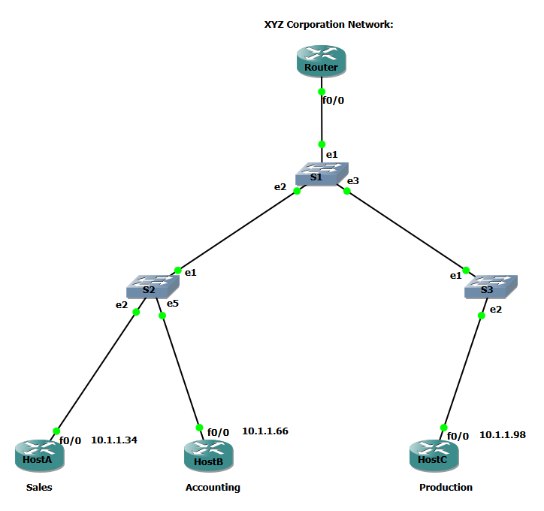

Figure: A screen shot of the topology with the required information as per step D.

1. **RUNNING CONFIFURATION OF ROUTER (9) ~no comments underline changes**

Router#show running-config

interface FastEthernet0/0

no ip address

duplex auto

speed auto

!

interface FastEthernet0/0.2

encapsulation dot1Q 2

ip address 10.1.1.33 255.255.255.224

!

interface FastEthernet0/0.3

encapsulation dot1Q 3

ip address 10.1.1.65 255.255.255.240

!

interface FastEthernet0/0.4

encapsulation dot1Q 4

ip address 10.1.1.97 255.255.255.248

!

interface Serial1/0

no ip address

shutdown

serial restart-delay 0

!

interface Serial1/1

no ip address

shutdown

serial restart-delay 0

!

interface Serial1/2

no ip address

shutdown

serial restart-delay 0

!

interface Serial1/3

no ip address

shutdown

serial restart-delay 0

line con 0

exec-timeout 0 0

privilege level 15

logging synchronous

line aux 0

exec-timeout 0 0

privilege level 15

logging synchronous

line vty 0 4

login

end

Router#

1. **ROUTING TABLE OF ROUTER (6)**

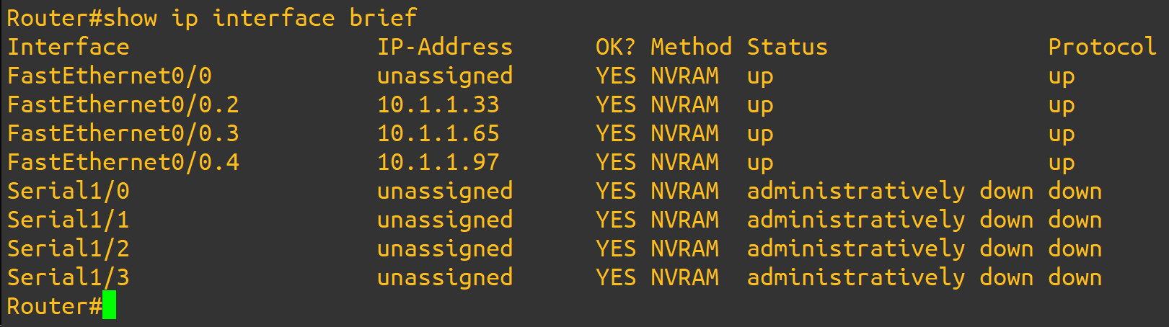

1. **SWITCH CONFIGURATION (S1,S2,S3) (6)**

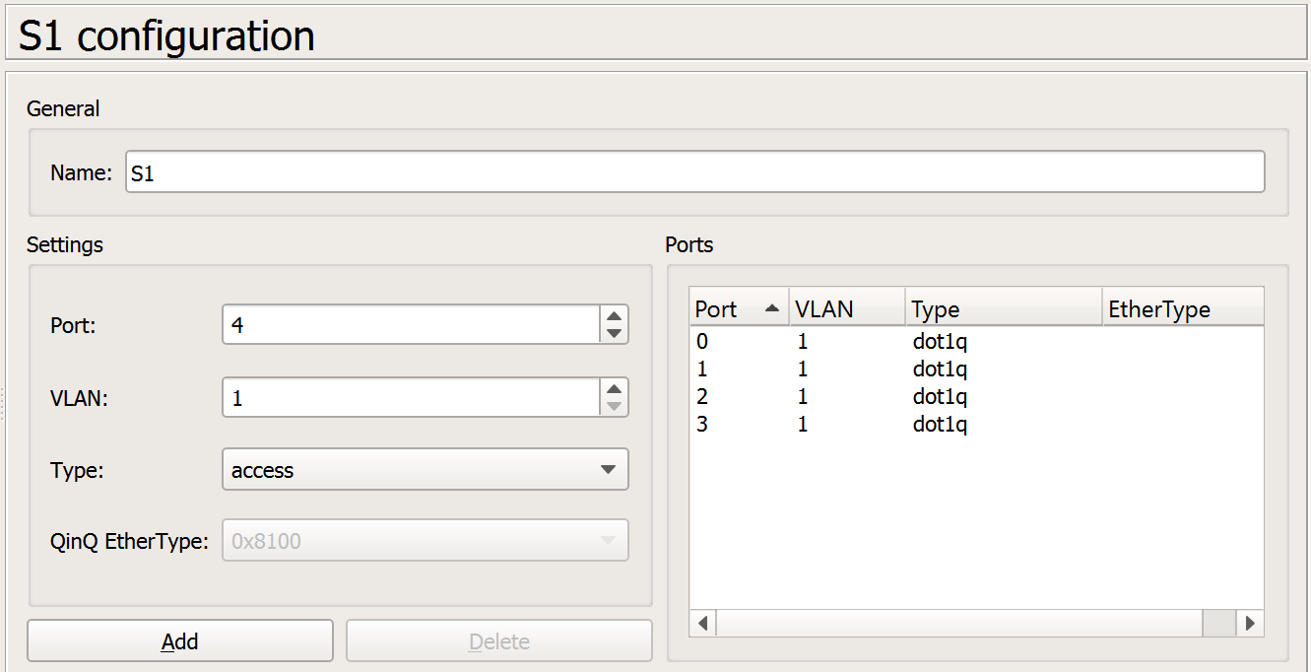

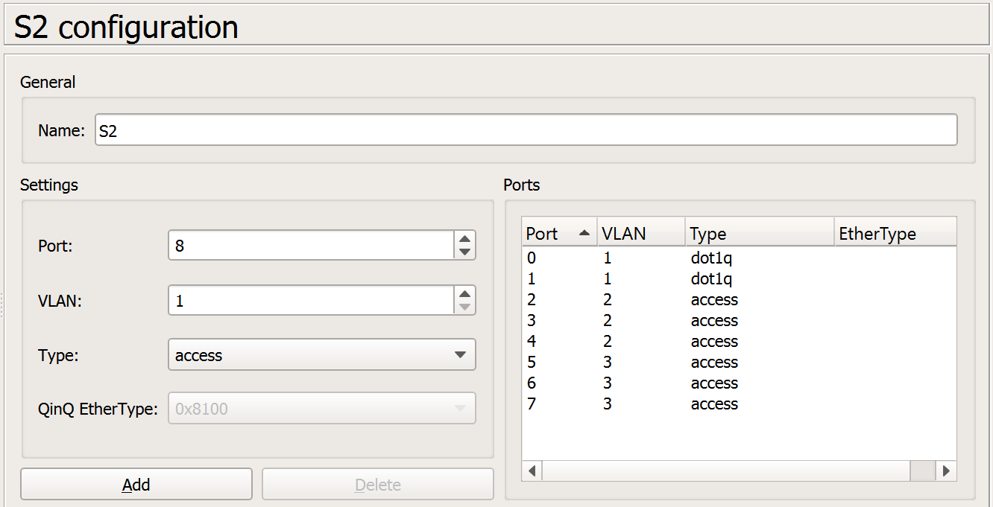

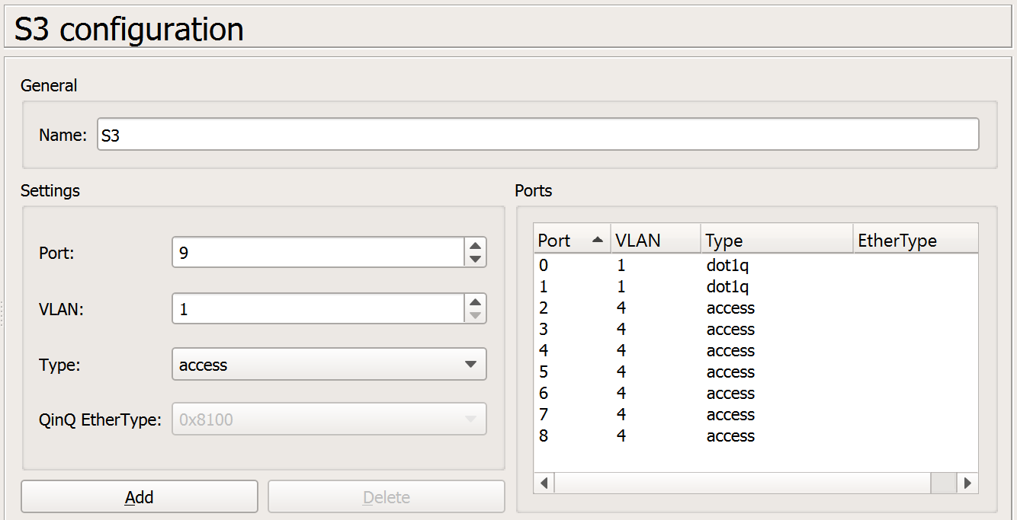

1. **ROUTING TABLE FOR (HostA,HostB,HostC) (6)**

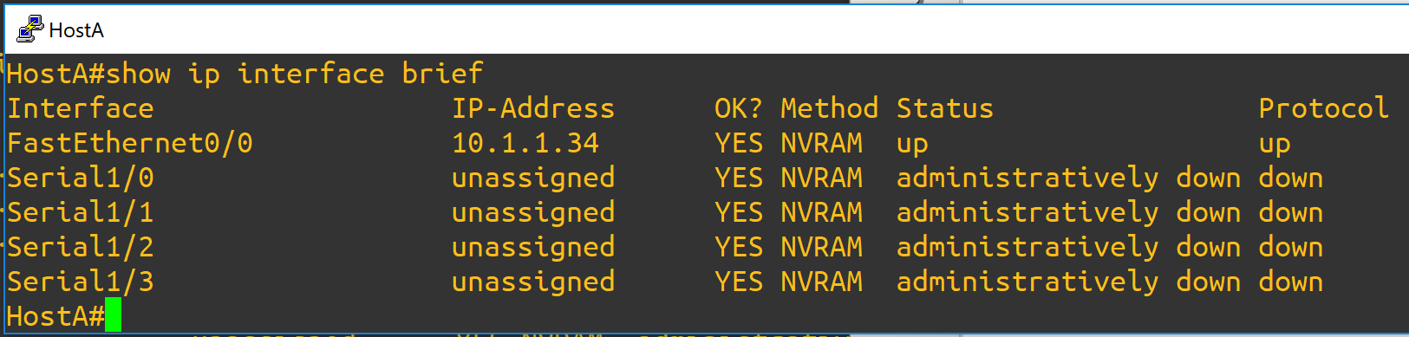

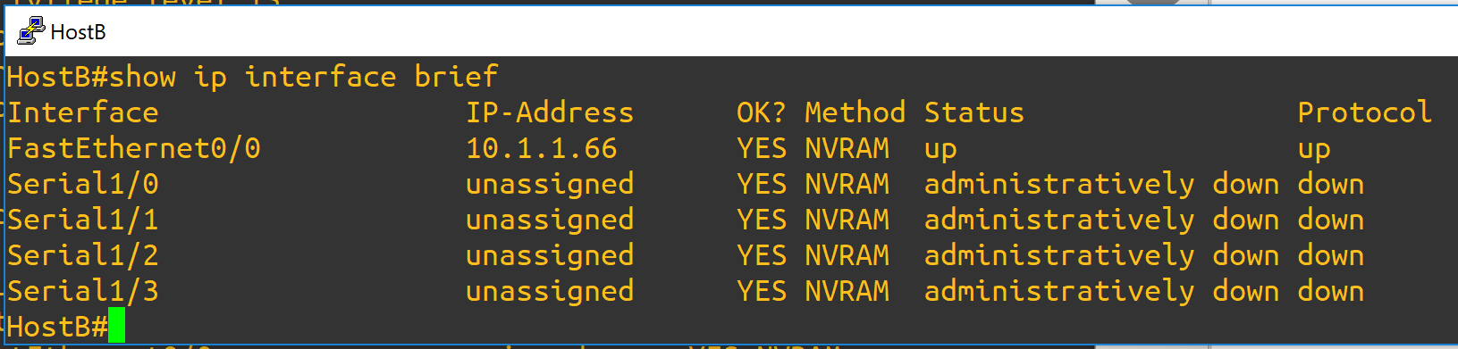

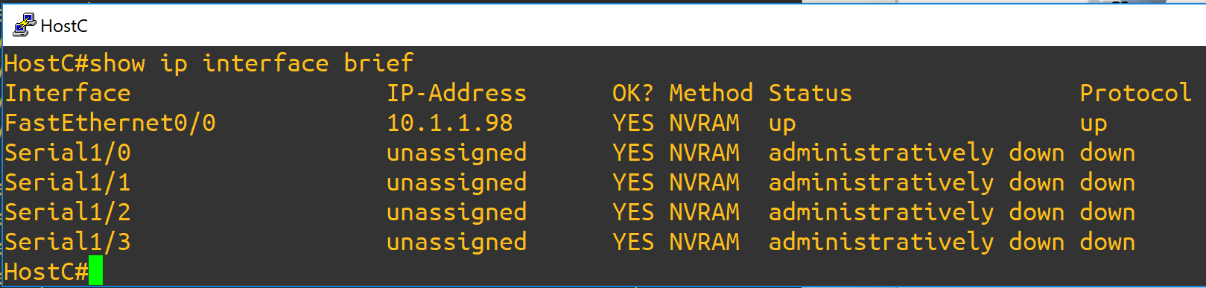

1. **PING RESULTS (4)**

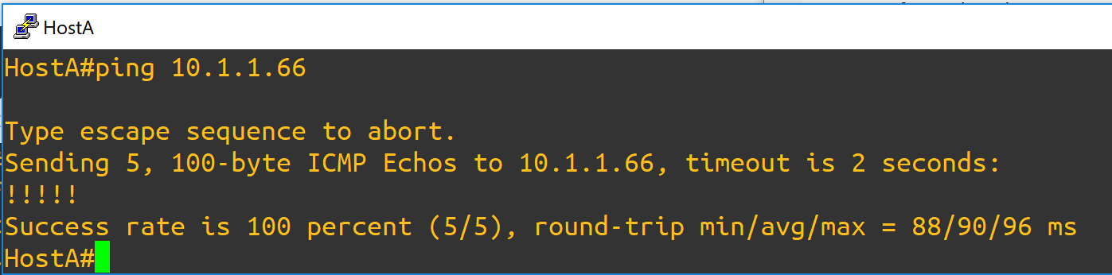

Form HostA to HostB

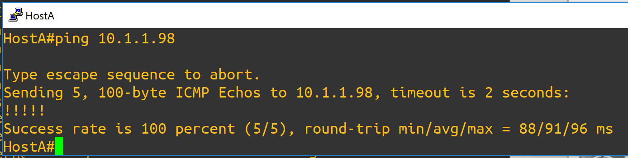

Form HostA to HostC